**Batch: HO-ML 1 Experiment Number: 03**

**Roll Number: 16010422234 Name: Chandana Galgali**

**______________________________________________________________________________**

**Aim of the Experiment:** To analyze the data and execute any two classification algorithms using RapidMiner

**Program/ Steps:**

1. Execute any two classification algorithms using RapidMiner tool
2. Analyze the results produced by Rapidminer

**Output/Result:**

**1) Golf Dataset using Decision Tree**

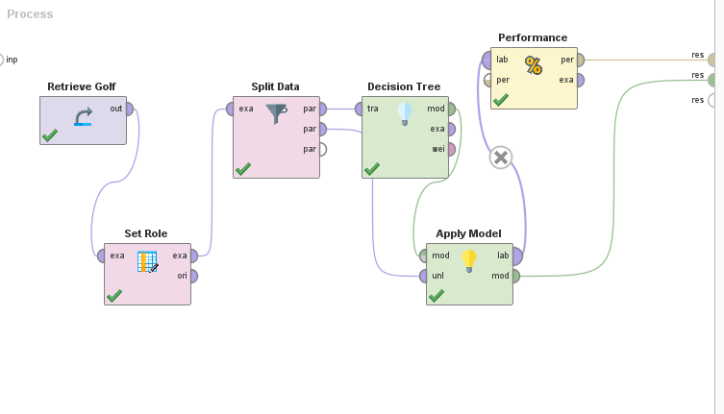**Decision Tree:**

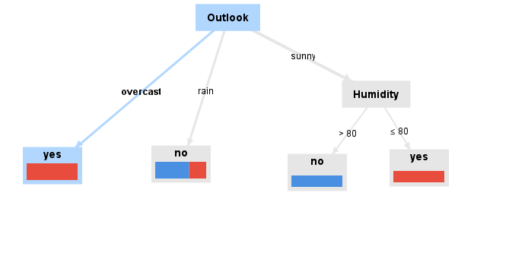

**Table:**

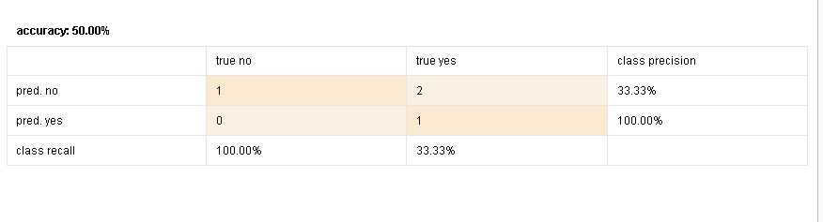

**2) Using Decision Stump**

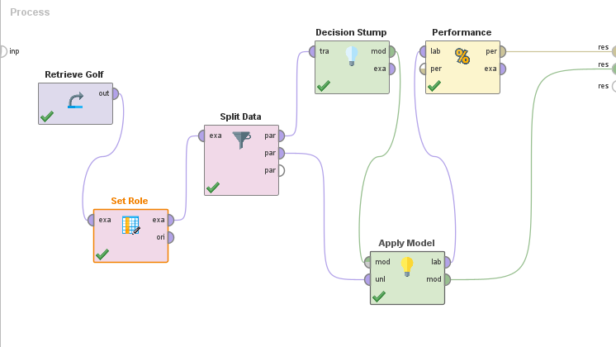

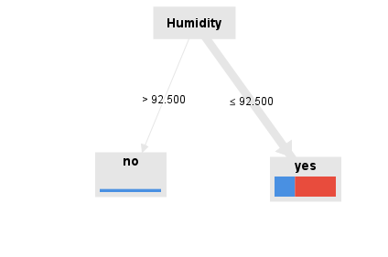

**3) Using a Different Dataset**

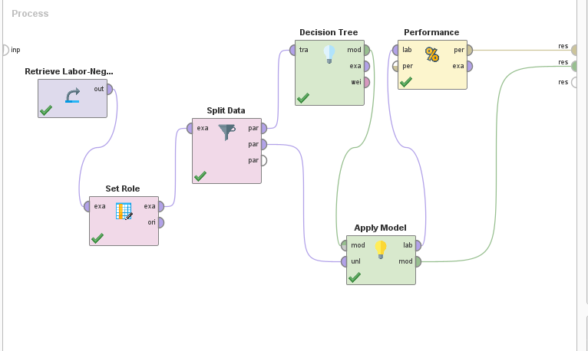

**Decision Tree :**

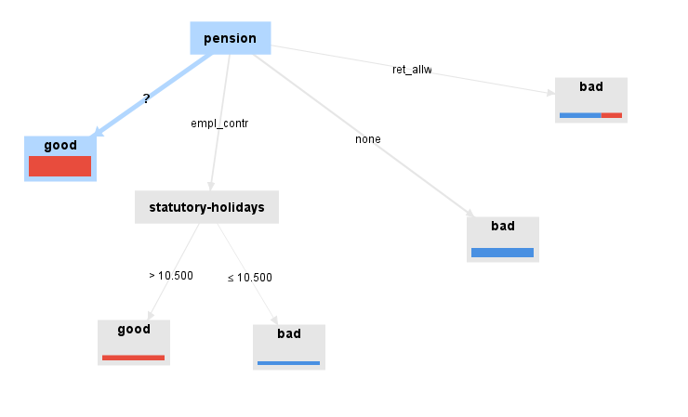

**4) Random Tree**

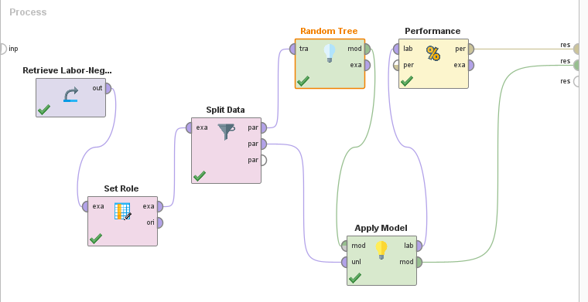

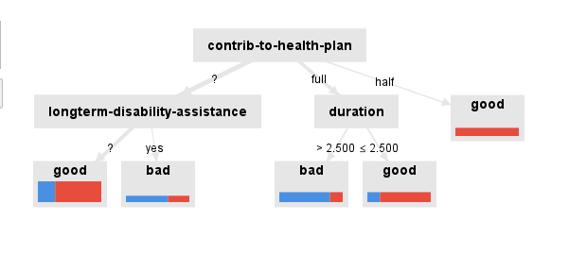

**Naïve bayes**

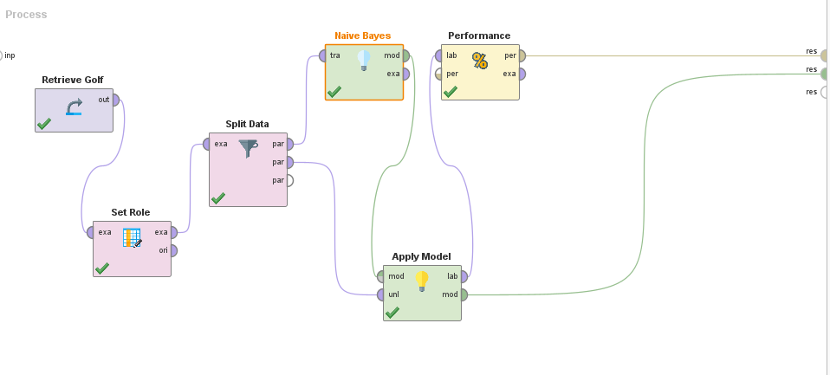

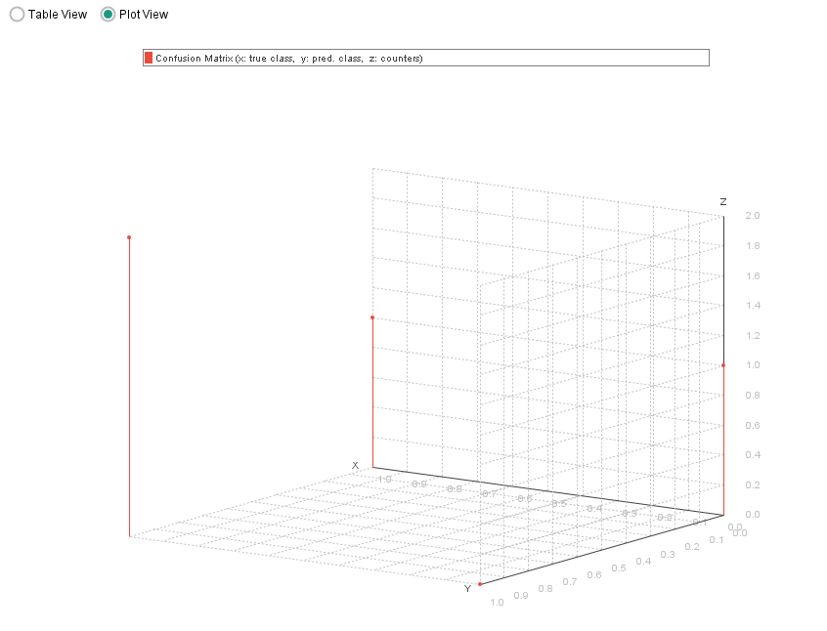

**Post Lab Question-Answers:**

1. **List any five open sources / freeware tools available for data mining.**
   1. RapidMiner - An open-source data science platform that provides a wide range of tools for data preprocessing, machine learning, and data analysis.
   2. WEKA (Waikato Environment for Knowledge Analysis) - A collection of machine learning algorithms for data mining tasks, including data preprocessing, classification, regression, clustering, and association rules.
   3. KNIME (Konstanz Information Miner) - An open-source data analytics platform that integrates various components for machine learning and data mining through a modular data pipeline.
   4. Orange - An open-source data visualization and analysis tool, with a visual programming interface for data mining, machine learning, and statistical analysis.
   5. Scikit-learn - A powerful Python library for data mining and data analysis, which includes a wide range of machine learning algorithms for tasks such as classification, regression, and clustering.

**Outcomes: Apply concepts of different types of Learning and Neural Network**

**Conclusion (based on the Results and outcomes achieved):**

In this experiment, we utilized RapidMiner, a powerful open-source tool, to analyze data and execute two classification algorithms. RapidMiner provides an extensive collection of data mining and machine learning algorithms, making it suitable for various tasks such as data preprocessing, classification, clustering, and association rule extraction. By applying the classification algorithms within RapidMiner, we were able to efficiently process the data, train the models, and evaluate their performance. The experiment demonstrated the practicality and versatility of RapidMiner in executing complex data analysis tasks, reinforcing its value as a tool for both educational and professional use in data mining and machine learning.

**References:**

Books/ Journals/ Websites:

1. Han, Kamber, "Data Mining Concepts and Techniques", Morgan Kaufmann 3nd Edition